**COMPUTER ORGANIZATION AND ARCHITECTURE LAB**

**(15B17CI373)**

**Project Title: CALCULATOR**

**Course Name: Computer Organization And Architecture Lab Batch: F1**



**Submitted by: Submitted to:**

1. Vaishali Ranjan (9920103013) Dr. Rashmi Kushwah 2. Anya Rathi (9920103001)

3. Khushi Kalra (9920103025)

**Department of CSE**

**Jaypee Institute Of Information Technology, Noida**

**Table of Content**

1. Problem Statement………………………………………………..
2. Introduction……………………………………………………….
3. List of technology/data structure used……………………………
4. Detailed design……………………………………………………
5. Implementation details and results………………………………..
6. Conclusion………………………………………………………...

**Problem Statement**

The aim of this project is to design a program that simulates the operation of a calculator system using 8086 simulator which can perform all the basic arithmetic operations like addition, subtraction, multiplication and division.

The user will be asked to enter the numbers on which he/she wants to perform the arithmetic operations. The user will be able to decide what arithmetic operation he/she wants to perform by giving some inputs provided to them. The smart calculator which we designed will print the output on the screen.

**Introduction**

Assembly language, also known as assembler language, is a low-level programming language that’s designed to communicate instructions with specific computer hardware and direct the flow of information. It does this using human-readable mnemonics (consisting of mnemonics like “LDA” to represent load accumulator) to form short code that makes it easier for the person trying to complete the work. These short codes are converted into machine learning language (binary, i.e., 1s and 0s) through the use of programs called assemblers.

A calculator is a device that performs arithmetic operations like addition, subtraction, multiplication, and division.

In this project we have computed the assembly language code (8086) to do the some basic arithmetic operations.

**List of Technology/Data Structure Used**

* Processor: Minimum 1 GHz; Recommended 2GHz or more
* Ethernet connection (LAN) OR a wireless adapter (Wi-Fi)
* Hard Drive: Minimum 32 GB; Recommended 64 GB or more
* Memory (RAM): Minimum 1 GB; Recommended 4 GB or above
* 8086 emulator

**Detailed Design**

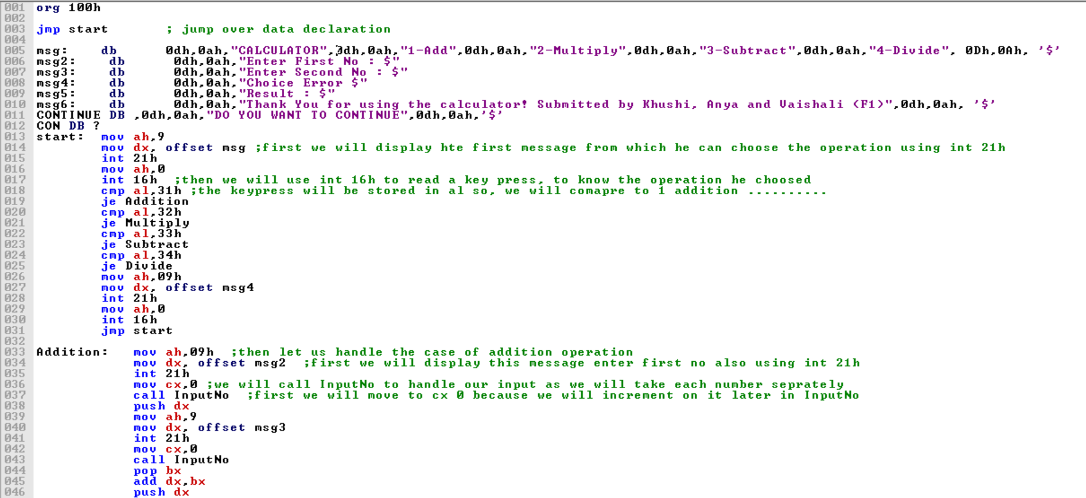

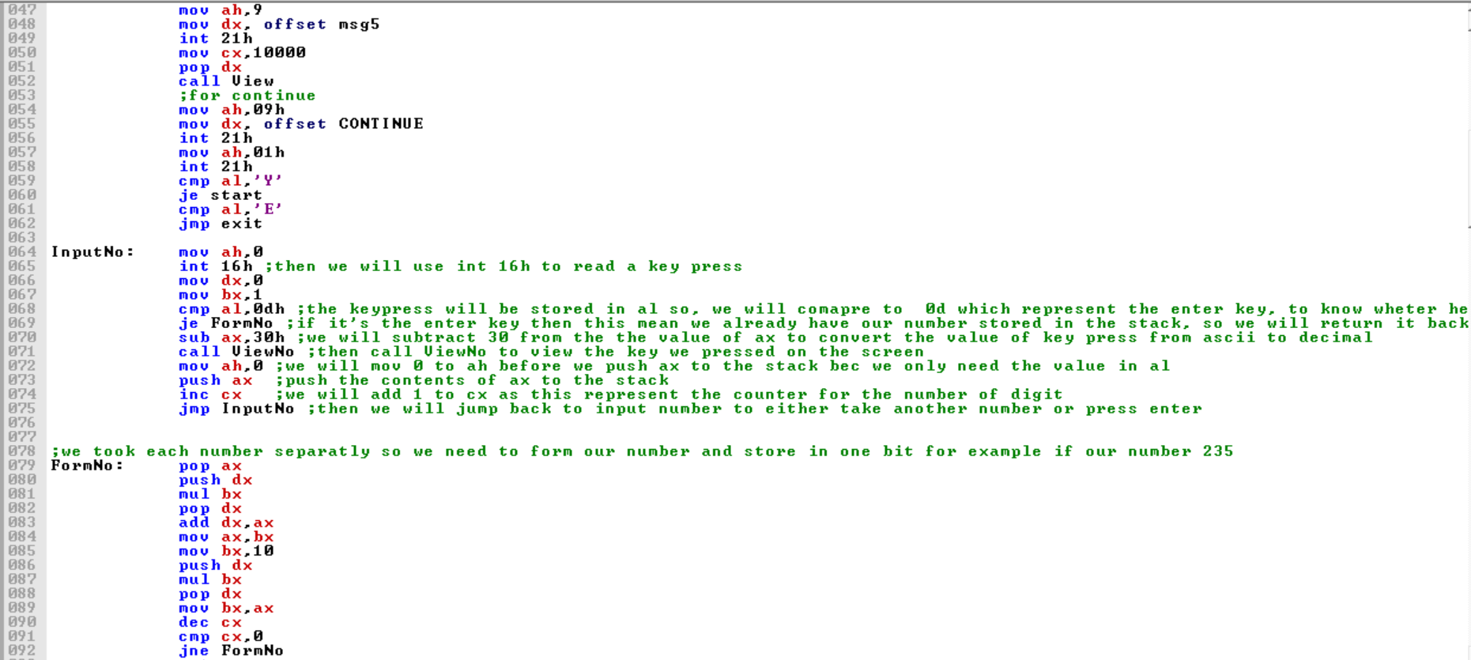 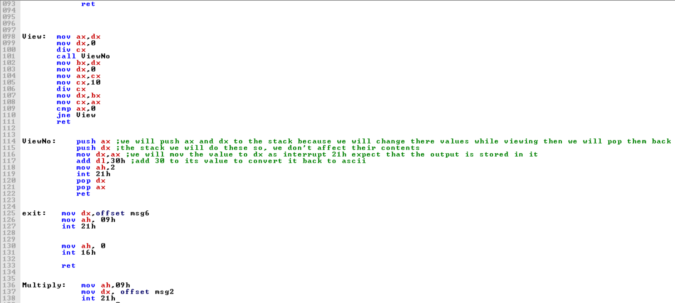

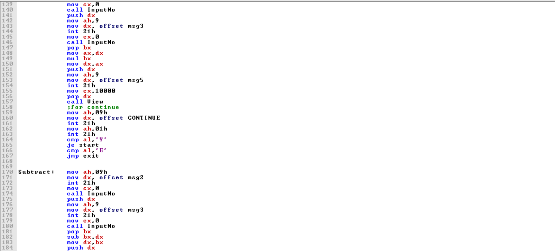

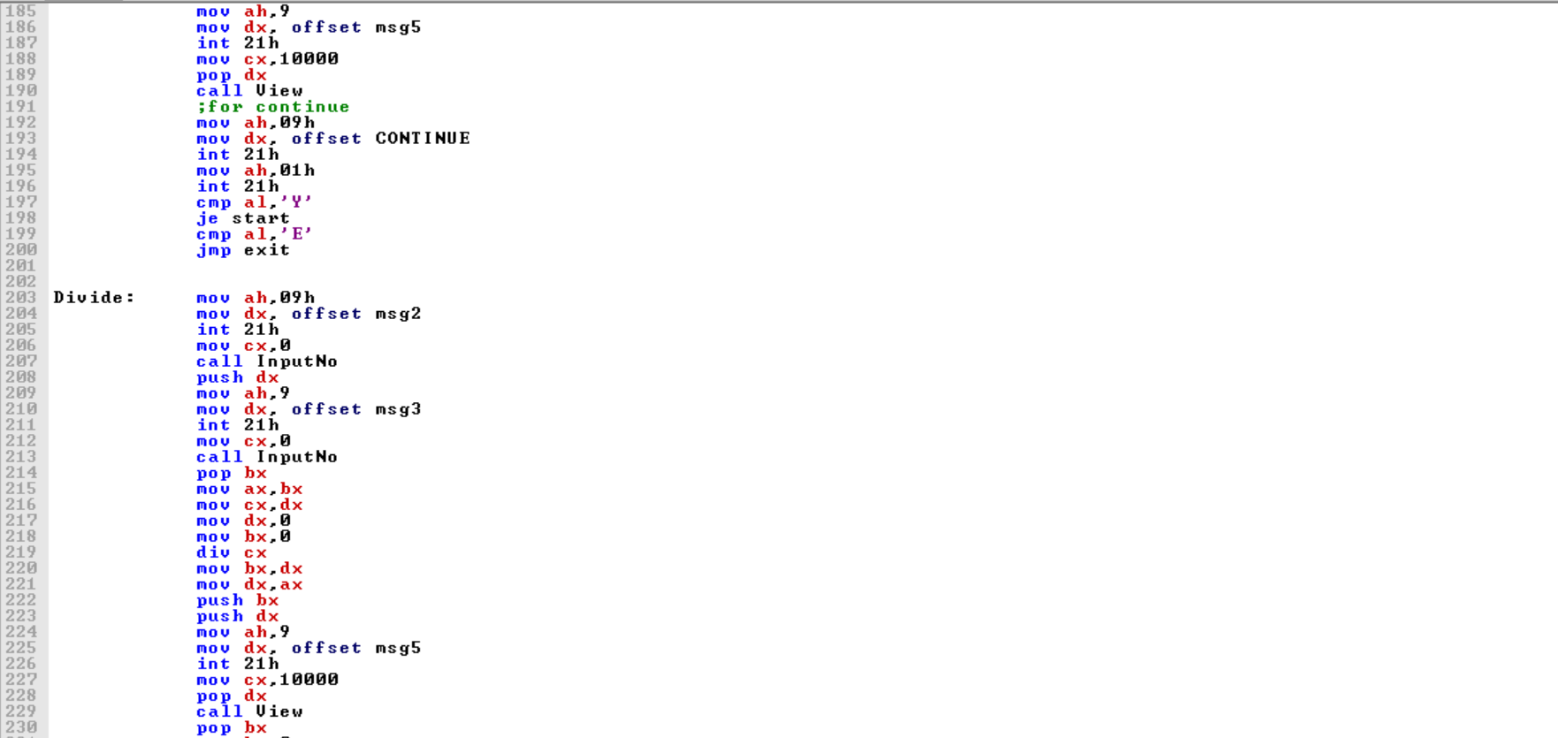

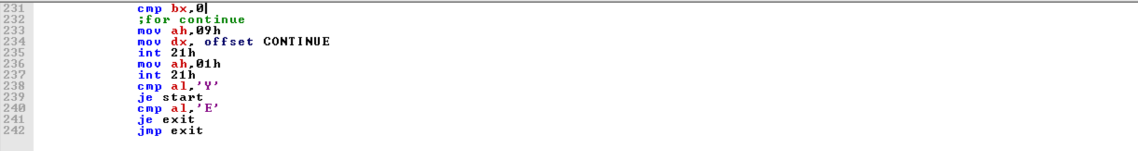

**Implementation Details And Results**

ADDITION:

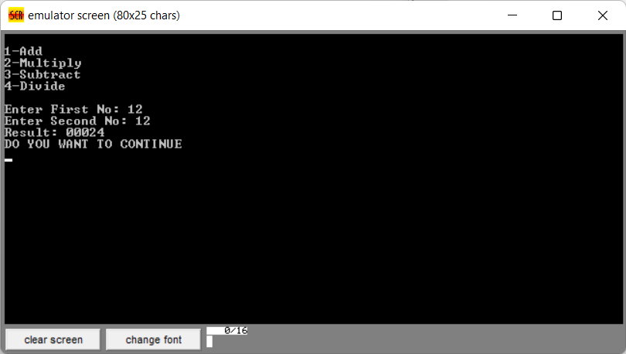 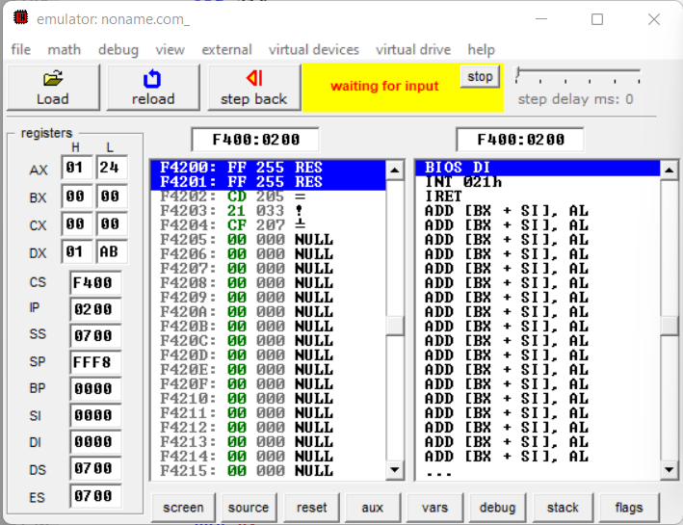

MULTIPLICATION:

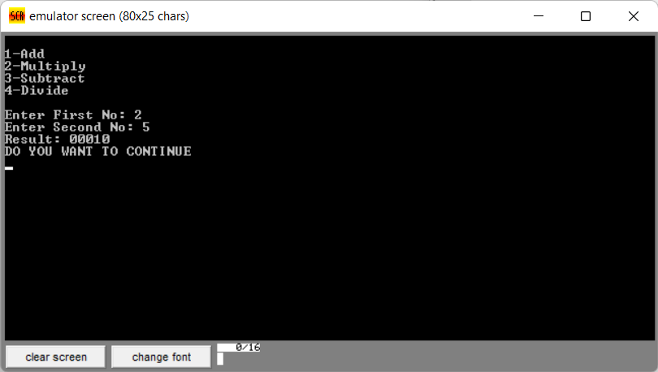 

SUBTRACTION:

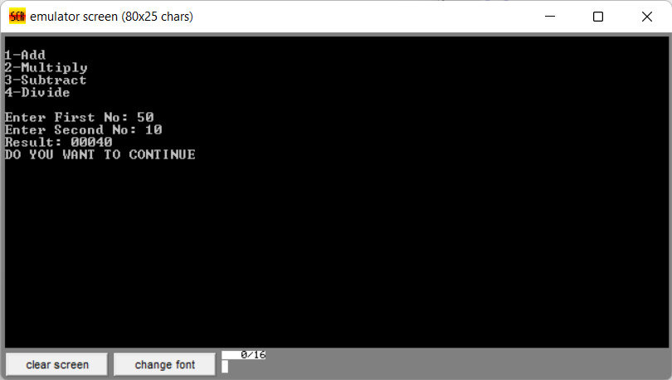 

DIVISION:

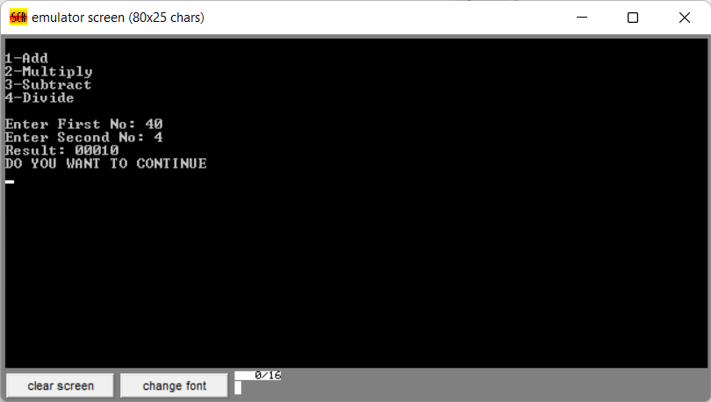 

**Conclusion**

After complete execution of code we were able to successfully compute the basic instruction of calculator like addition, subtraction, multiplication, division in 8086 emulator.

Assembly language is not a day-to-day language but a computer engineering developer should know the assembly language so that by the piece of code one can understand what is going in the central processing unit and most important thing about assembly language is where a person wants to work at byte-bit level.